
Episode 2: Let’s Build
English
Reading: Finish the story

Steve had lots of trouble building his house. Read the story and circle the adjectives.
Night was coming. That means only one thing…monsters. You look around but you can’t build a house anywhere. The ground is too rocky and the mountains are too steep. The full moon is rising above you, when you hear the howl of the wolves.
Then you notice a small opening in the face of the mountain, a cave! This could be good news, or bad news. You look inside. It is dark, it is quiet and it is a little smelly, too. Something was living here not too long ago. You have no choice but to enter the cave and explore. The cave is wide and deep, you don’t know how deep, but you have to find out because a tall shadow appears at the entrance of the cave behind you.
Finish the story. What are you going to do?

Episode 2: Let’s Build
English
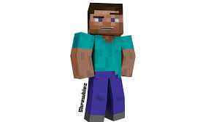
Describing places and things
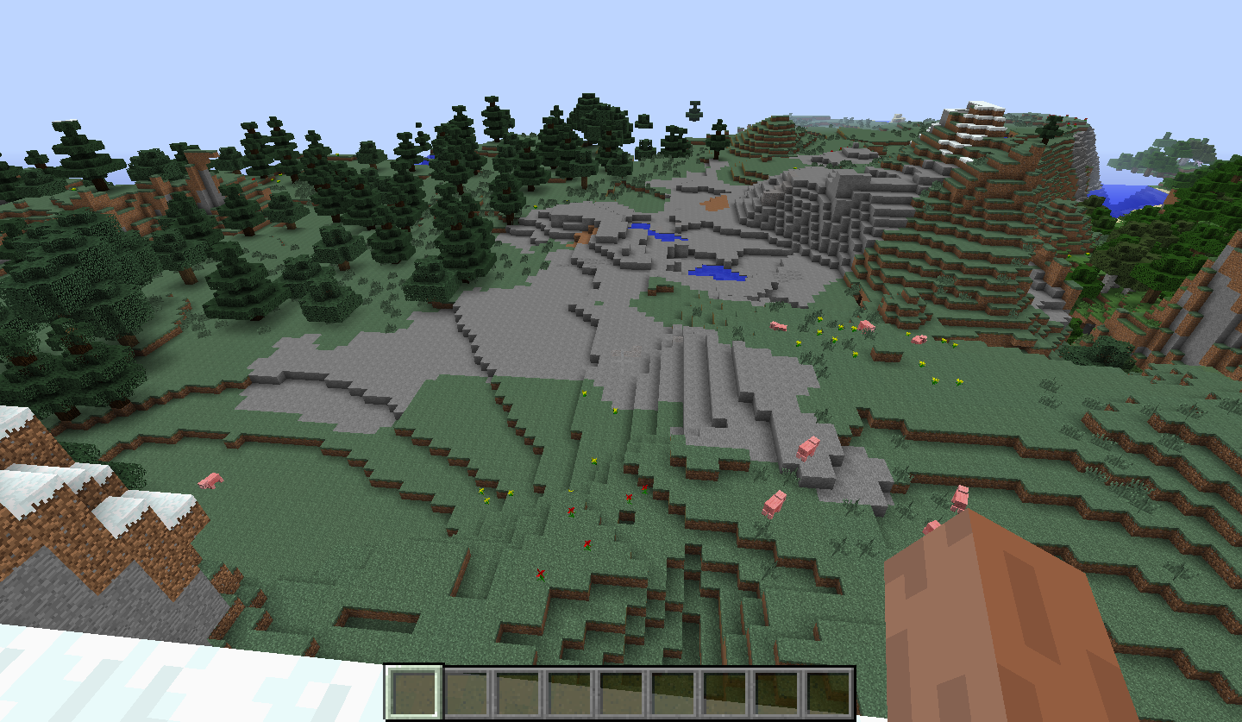
Steve needs your help! Where do I build my home? Look at the pictue and circle the area where Steve should build his home.
flat | low | rocky | hidden
high | beautiful | top | bottom
open | green | foresty | safe
Using the above words, write 7 sentences to describe why it is the best place.
1.
2.
3.
4.
5.
6.
7.
Get the right tools!
What’s best for mining and building? Choose the best tools for mining and crafting.
Example: Obsidian is strong. Diamonds are colourful.
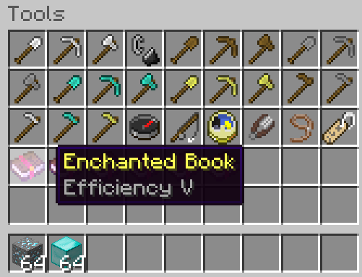
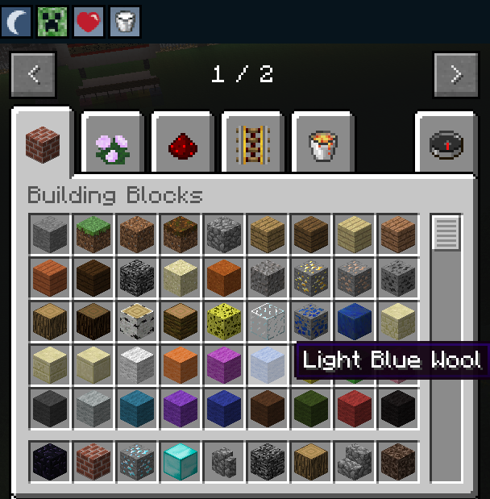

Write seven sentences to explain your choices.

1.
2.
3.
4.
5.
6.
7.

Creepers, I hate them!
Looks like Steve really needs your help.
What is happening in this picture? What should Steve do?!?
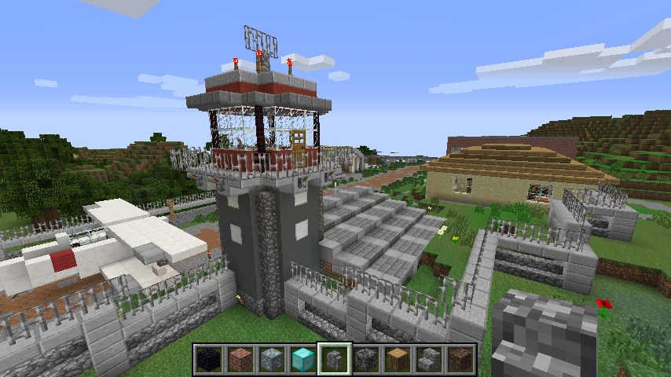
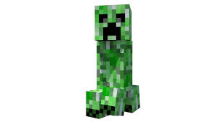
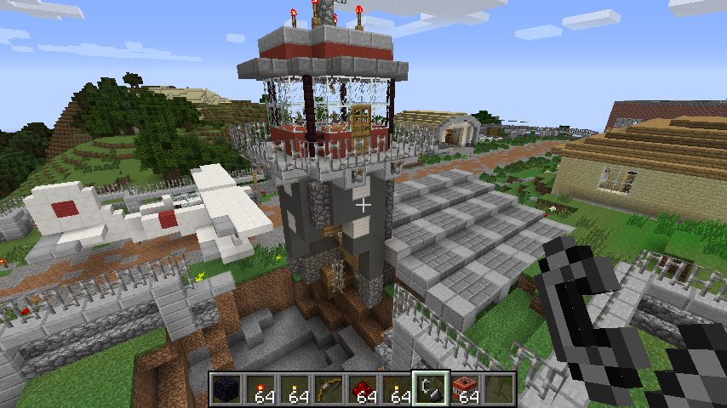

Rearrange the following sentences to describe his situation:
1. A creeper / building / up / blew / the

2. The building / damaged / is / badly.

3. The plane / all / not / is / damaged / at.

4. The walls / the / are / stairs / broken / and.

5. There is / the / hole / in / a / large / ground.

6. Steve / rebuild / strong / needs / material / to.

7. The fence it / holes / two / large / has / in.

Design time
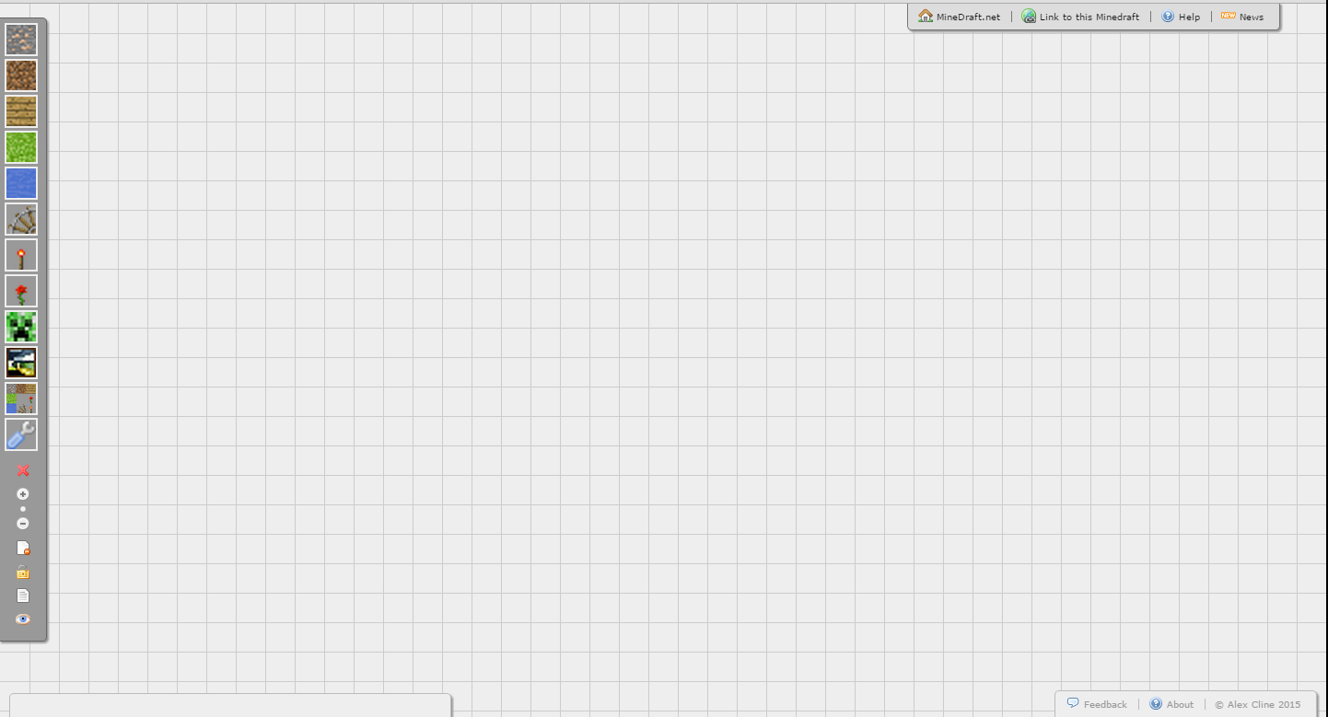
Design your own item. Explain what it is.

